**Spring 2024: CS5720 Neural Networks & Deep Learning - ICP-3**

**Sai Preetham Nagaswaram (700743350)**

GitHub Link:[https://github.com/Saipreethamnagaswaram/Neural-Network-Deep-Learning/tree/main/Assignment3](https://github.com/Saipreethamnagaswaram/Neural-Network-Deep-Learning/tree/main/Assignment1)

1. **Create a class Employee and then do the following**

• Create a data member to count the number of Employees

• Create a constructor to initialize name, family, salary, department

• Create a function to average salary

• Create a Fulltime Employee class and it should inherit the properties of Employee class

• Create the instances of Fulltime Employee class and Employee class and call their member functions

**solution:**

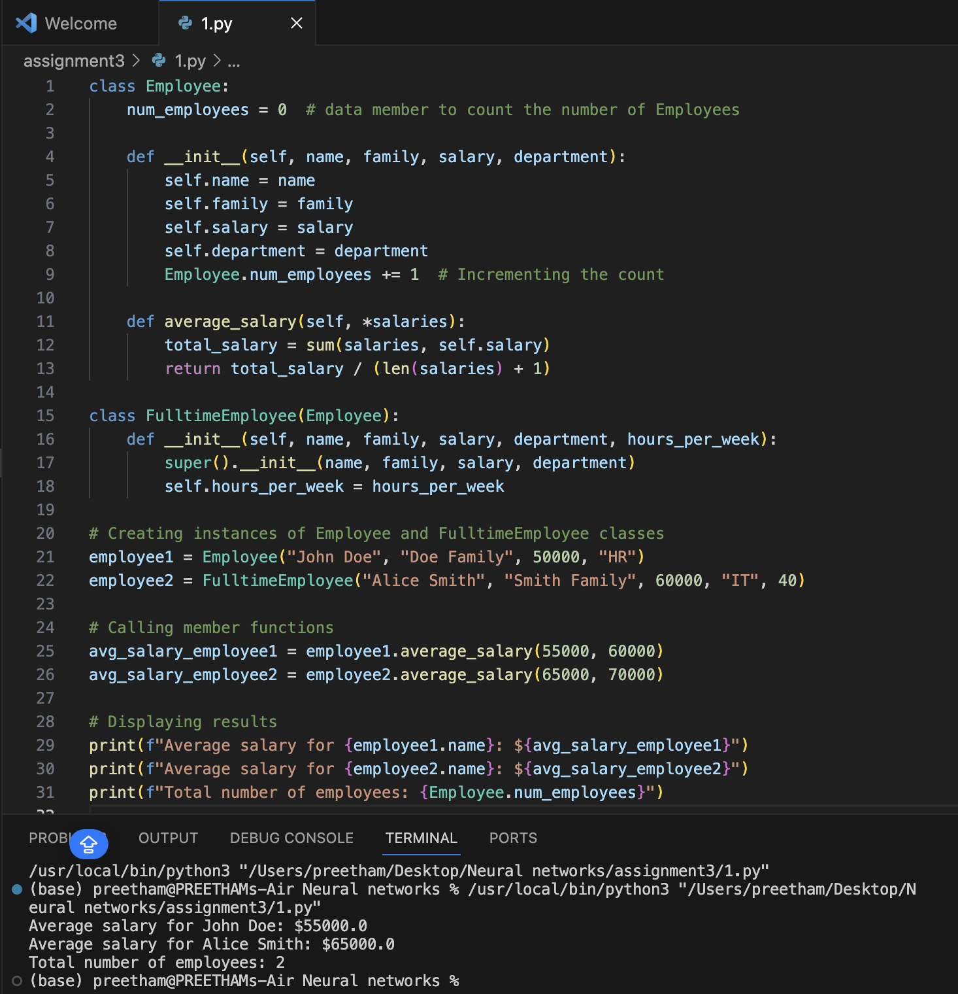

1. **Numpy**

Using NumPy create random vector of size 20 having only float in the range 1-20.

Then reshape the array to 4 by 5

Then replace the max in each row by 0 (axis=1)

(you can NOT implement it via for loop)

**Solution:**

